OPgain

Mechanical Assembly Guide

**Achikam Dadon, Naama Sharabi, Shlomo Marmor, Shahar Ganani, Yinon Sasson**

**OPgain**

## Mechanical Assembly Guide

Table of Contents

**OPgain** 1

Mechanical Assembly Guide 1

Full Assembly Requires 1

Module Mechanical Assembly: 2

Step 1: 2

Step 2: 3

Step 3: 3

Mechanical Box Assembly: 3

Step 1: 3

Step 2: 3

Step 3: 4

Step 4: 4

Step 5: 5

Full Assembly Requires:

1. 1 X Chassis with Inserts
2. 1 X Chassis Top Cover
3. 2 X Mounting Ear
4. 10 X Heat Spreader (1 per module)
5. 10 X Top Cover (1 per module)
6. 3 X BushBar
7. 2 X Bushbar Support

### A blue letter and black background Description automatically generatedModule Mechanical Assembly:

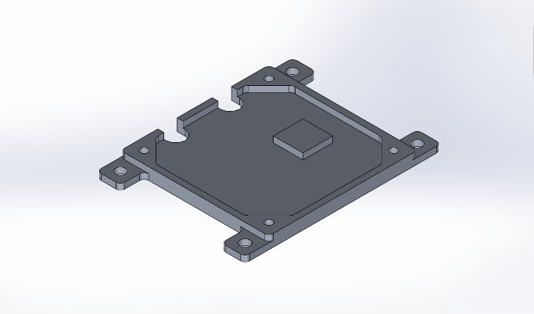 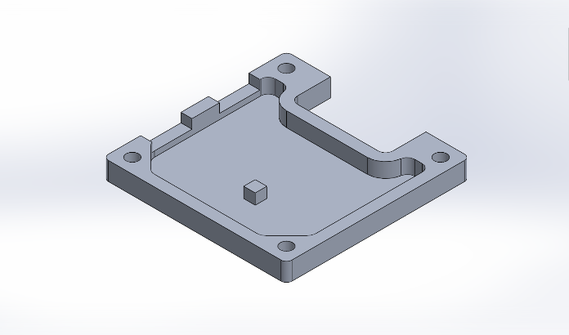

Bottom

Top

Step 1: Apply grease THERMAL GREASE TC2 20G ND to pads, marked with red arrows, on mechanics (top and bottom).

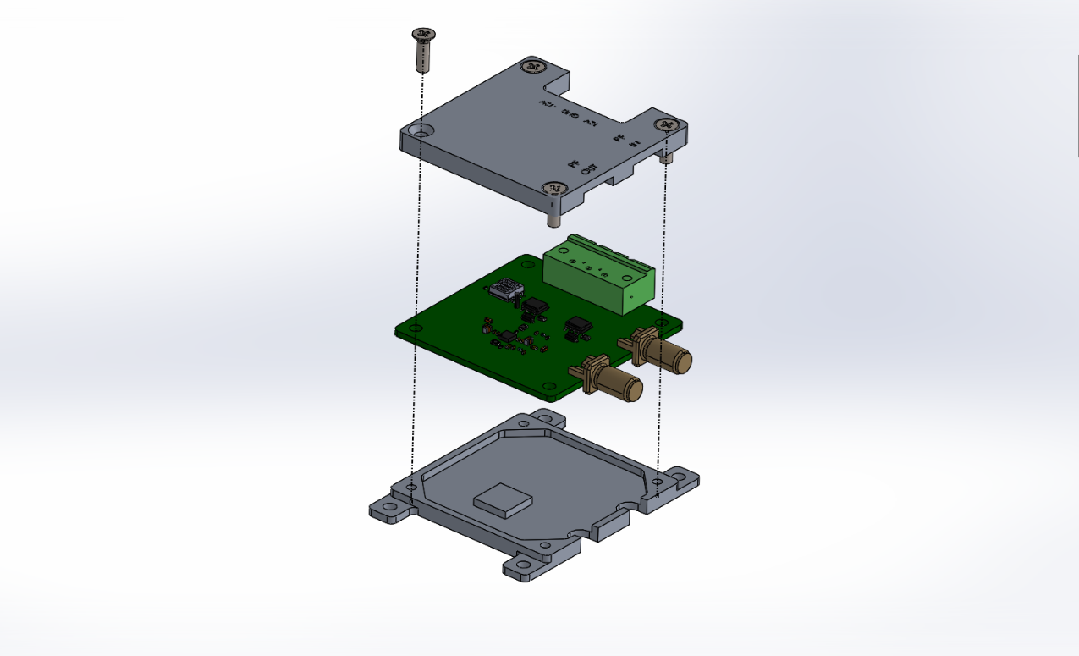

Step 2: Assemble Module as shown in the image above using 4 DIN965 M3X10 screws.

Step 3: Screw Modules into Mechanical Box using 4 ISO7045 M3X6 (PHILLIPS PAN HEAD) screws. (If using Mechanical Box)

### A blue letter and black background Description automatically generatedMechanical Box Assembly:

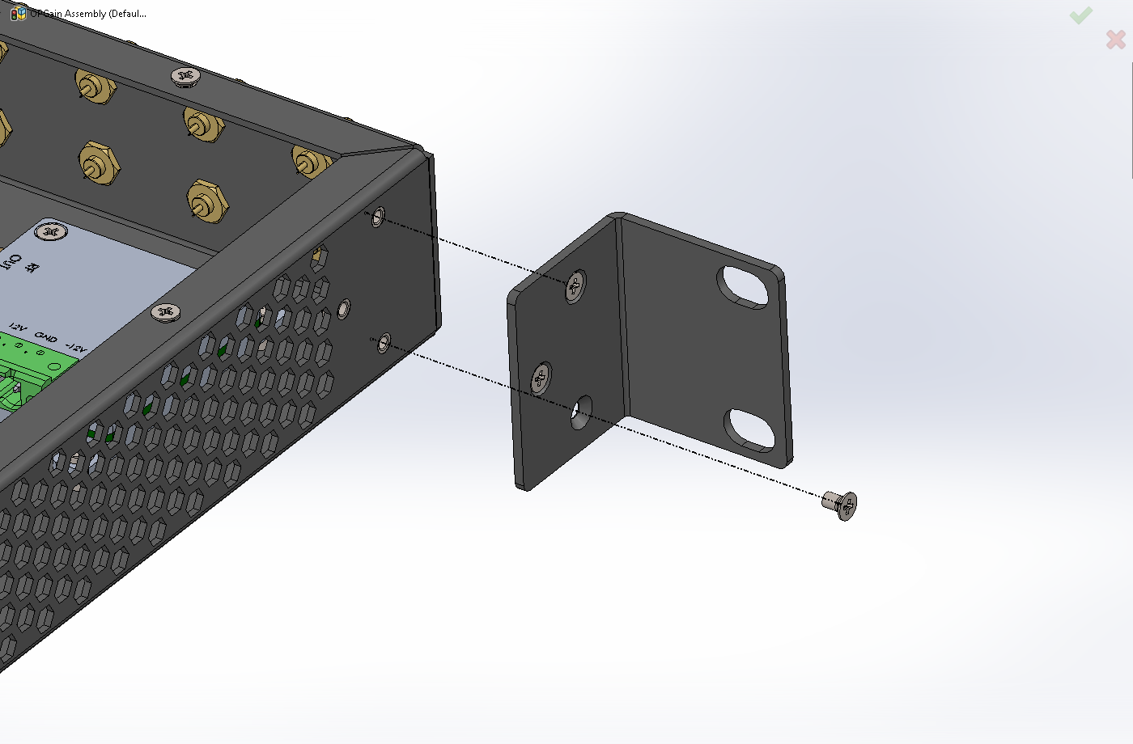

Step 1: Connect Rack Mount Ears to Mechanical Box (if relevant) using 3 DIN965 M3X6 screw as seen in the image above.

Step 2: Voltage Assembly requires 3 cable plugs per module with 4mm hole (overall 30 each for ten channels) and recommended purchase of different color for connectivity clarity.  
In the diagram below red denotes +12V, black -12V and yellow is GND.

Step 3: Place Bushbar on the BushBar Supports levels to create uniform voltage across each row with suggested placement of +12V to top, GND in the middle, and -12V on the bottom.

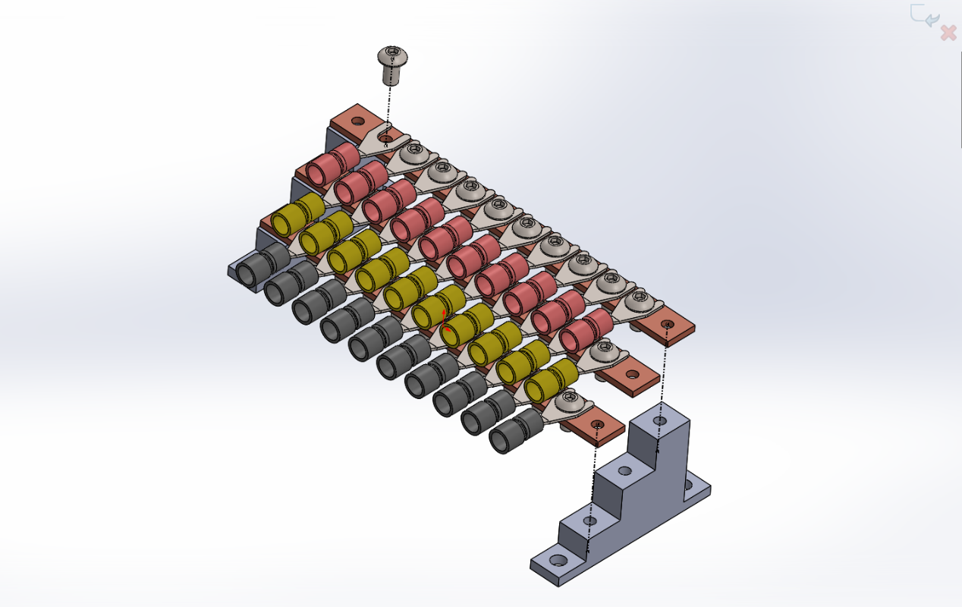

Step 4: For cable plugs assembly 46 X ISO7045 M4X8 (PHILLIPS PAN HEAD) are needed for full assembly as seen in the image above.

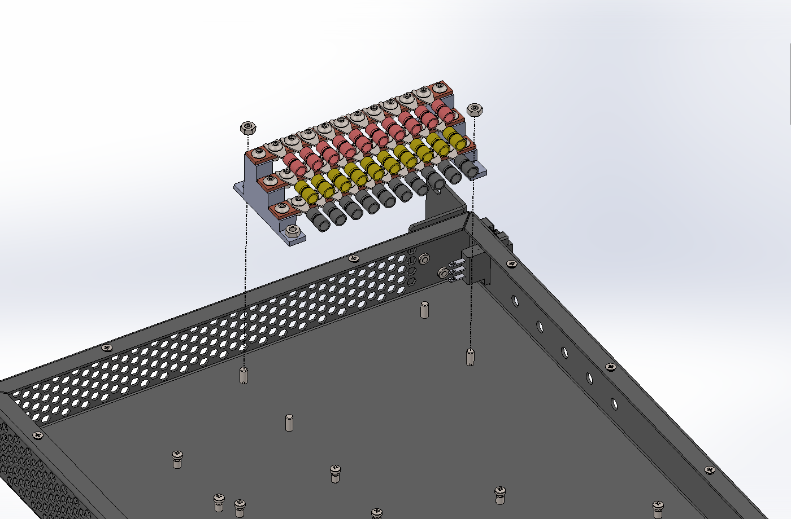

Step 5: For assembly of the BushBar to Mechanical Box Chassis 4 ISO4032 M4 are needed as seen in the image above.